**Rhythmic Tunes: Your Melodic Companion**

Project Report

Frontend Development with React.js

Prepared by:

**Team Leader:**

Rakshaya.P

**Team Members:**

1. Rithika.J
2. Roshini.E.R
3. Pavithra.S

Date: September 2025

# Introduction

This project, Rhythmic Tunes: Your Melodic Companion, is a React.js-based frontend application designed to provide users with an immersive music streaming experience. It focuses on building a user-friendly interface and leveraging modern web development technologies.

# Project Objectives

The primary goal of Rhythmic Tunes is to provide a seamless platform for music enthusiasts. Objectives include:

* User-Friendly Interface: An intuitive interface for exploring, saving, and sharing tracks.
* Comprehensive Music Streaming: Features for organizing and managing music content.
* Modern Tech Stack: Using React.js for efficient, dynamic, and responsive UI.

# Project Structure

The application follows a modular structure, making it maintainable and scalable. Key folders include:

* src: Contains assets, components, and main entry files.
* Components: Reusable UI parts.
* App.jsx: Root component handling layout and routing. - main.jsx: Entry point of the React app.

# Prerequisites

Before setting up the project, the following tools are required:

* Node.js and npm: JavaScript runtime and package manager.
* React.js: Library for building UI components.
* Git: Version control system.
* Development Environment: VS Code, Sublime, or WebStorm.

# Setup Instructions

To set up the project locally:

1. Install Node.js and npm.
2. Install Git for version control.
3. Create a new React app using: npx create-react-app my-react-app
4. Navigate into the project folder: cd my-react-app
5. Install dependencies: npm install
6. Start the development server: npm start

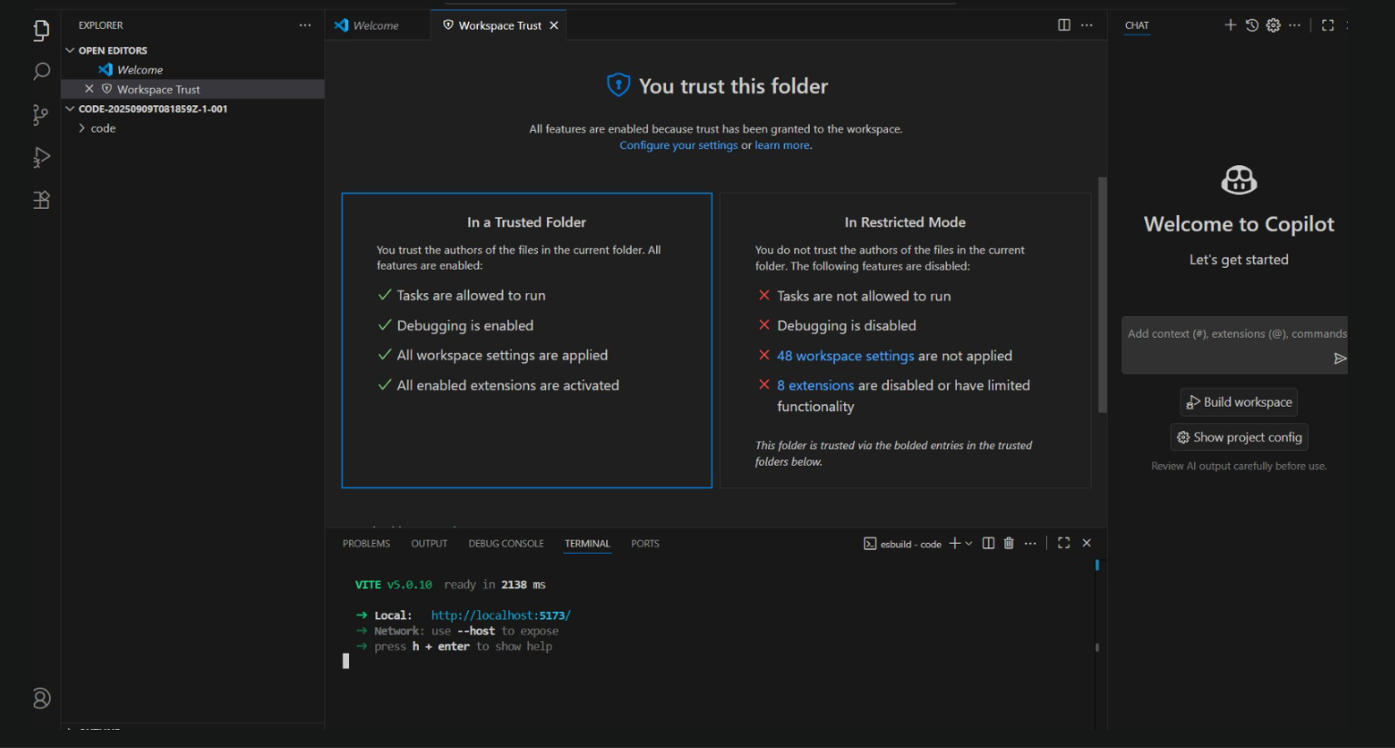

# Running the Application

After setup, run the following:

- npm start

This launches the development server at http://localhost:3000. If successful, the homepage of Rhythmic Tunes will be displayed.

# Conclusion and Future Enhancements

Rhythmic Tunes provides a strong foundation for a modern music streaming application.

Future improvements may include:

* Adding authentication for user profiles.
* Enhancing UI with animations and themes.
* Expanding features with playlist sharing and recommendations.